RAJALAKSHMI ENGINEERING COLLEGE
RAJALAKSHMI NAGAR, THANDALAM – 602 105



CS23532 - Computer Networks
LABORATORY NOTEBOOK

NAME: MANISHA P
YEAR: 3rd Year
BRANCH: Artificial Intelligence and Data Science REGISTER NO: 2116231801096
SEMESTERS: V

YEAR: 2025 - 2026



RAJALAKSHMI ENGINEERING COLLEGE (AUTONOMOUS)
RAJALAKSHMI NAGAR, THANDALAM - 602 105

BONAFIDE CERTIFICATE

NAME……………………………………………………………………………… ACADEMIC YEAR…………SEMESTER…………. BRANCH …………….

UNIVERSITY REGISTER NO:

This Certification is the Bonafide record of work done by the above student in the
CS23532 - Computer Networks Laboratory during the year 2025 - 2026.

Signature of Faculty - in - Charge

Submitted for the Practical Examination held on

Internal Examiner External Examiner

INDEX

S.  No | Title | QR Code | Sign
1. | Basic networking commands in Linux and Windows | 
2. | Learning and Assignment of IP Address manually to computers | 
3. | Study of different types of Network Cables and Crimping of cable with RJ45 connector | 
4. | Implement packet sniffing using raw sockets in python | 
5. | Develop a customized ping command to test the server connectivity | 

6. | Building anonymous FTP Scanner using ftplib module | 
7. | Develop a simple calculator using XMLRPC | 
8. | Develop a program to create reverse shell using TCP sockets | 
9. | Design a simple topology and configure with one router, two switches and PCs using Cisco Packet Tracer | 
10. | Customize Switch with Network Modules using Cisco Packet Tracer | 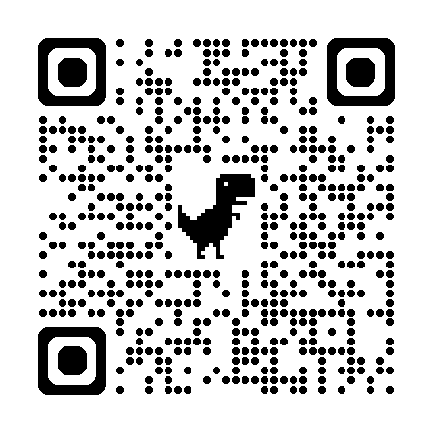
11. | Examine Network Address Translation (NAT) using Cisco Packet Tracer | 

12. | Nmap to discover live hosts using ARP scan, ICMP scan, and TCP/UDP ping scan in TryHackMe Platform. | 
13. | Demonstrate network forensics using PcapXray tool | 
14. | To capture, save, and analyze network traffic on TCP / UDP / IP / HTTP /  ARP /DHCP /ICMP /DNS using Wireshark Tool | 
15. | To Analyze the different types of servers using Webalizer tool | 

